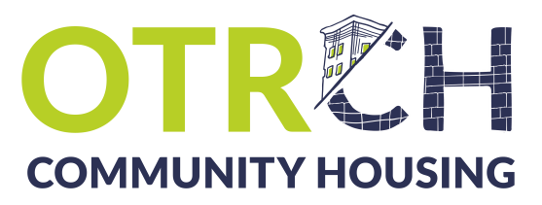

Beyond the Building Campaign

Service Center Expansion & Renovation

The renovation and expansion of Over-the-Rhine Community Housing’s Service Center will ensure that we are in a position to continue serving low-income residents and our community’s most vulnerable populations by offering affordable housing options and supportive services. Over-the-Rhine is at a critical juncture where affordable housing must be prioritized to maintain the social, racial, and economic diversity that makes this neighborhood so unique. Please join us and support equitable development by contributing to The Over-the-Rhine Community Housing Service Center Expansion Project today!

Donor Information

Name(s)

Contact person, if organizational donor

Address

City, State, Zip Code

Phone

Email
Pledge Information*
☐ I/we pledge a gift of $_________________ to be paid in equal, annual installment(s) for _______ year(s).
________________________________________________________________________________________________________________
Signature Date
*We must reach $750,000 in both gifts and pledges before we can begin collecting pledges. We will be in touch with more information regarding pledge collections as the campaign progresses.

Want to make your contribution today?
Enclosed is my/our tax deductible gift of: ☐ $5,000 ☐$1,500 ☐ $750 ☐ $500 ☐ $100 ☐ other _________
Over-the-Rhine Community Housing
Please make checks payable to: 114 W. 14th Street
Cincinnati, OH 45202
Acknowledgement Information
Please use the following name(s) in all acknowledgments: _____________________________________________
___________________________________________________________________________________________________________
☐ I (we) wish to have our gift remain anonymous.

